Azure devops
Link : https://dev.azure.com/kiet2174802010597/0103_Team07_ContentHub

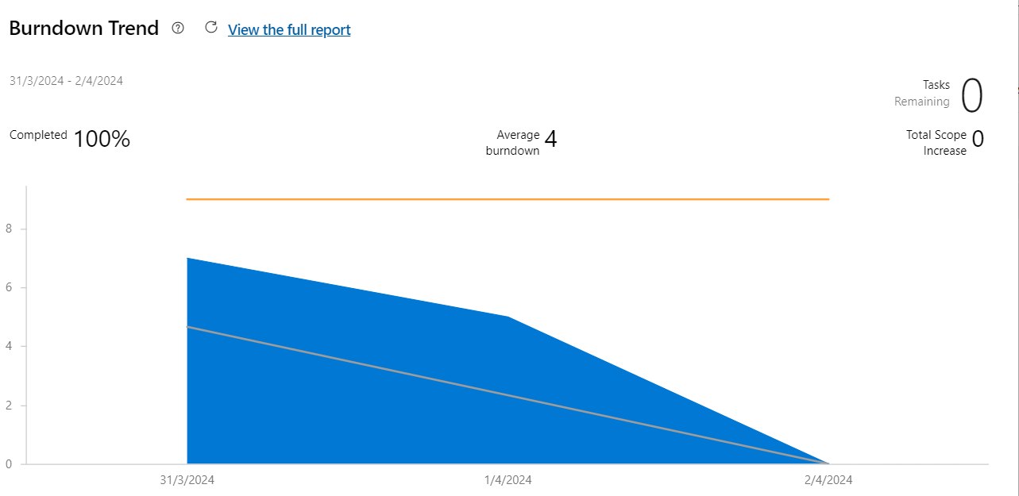
Sprint – planning tuần 1

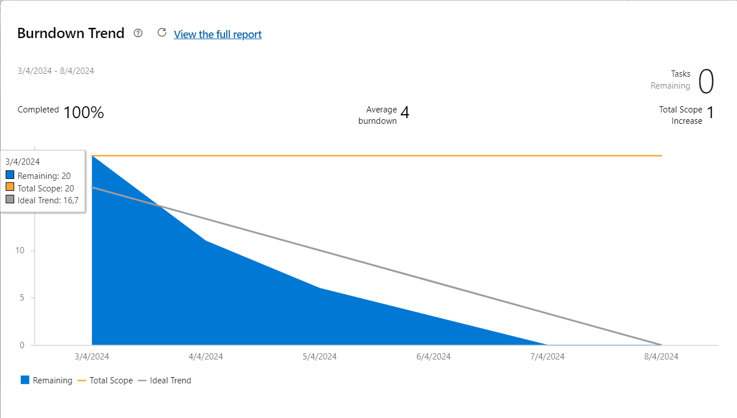
Sprint – Planning 2

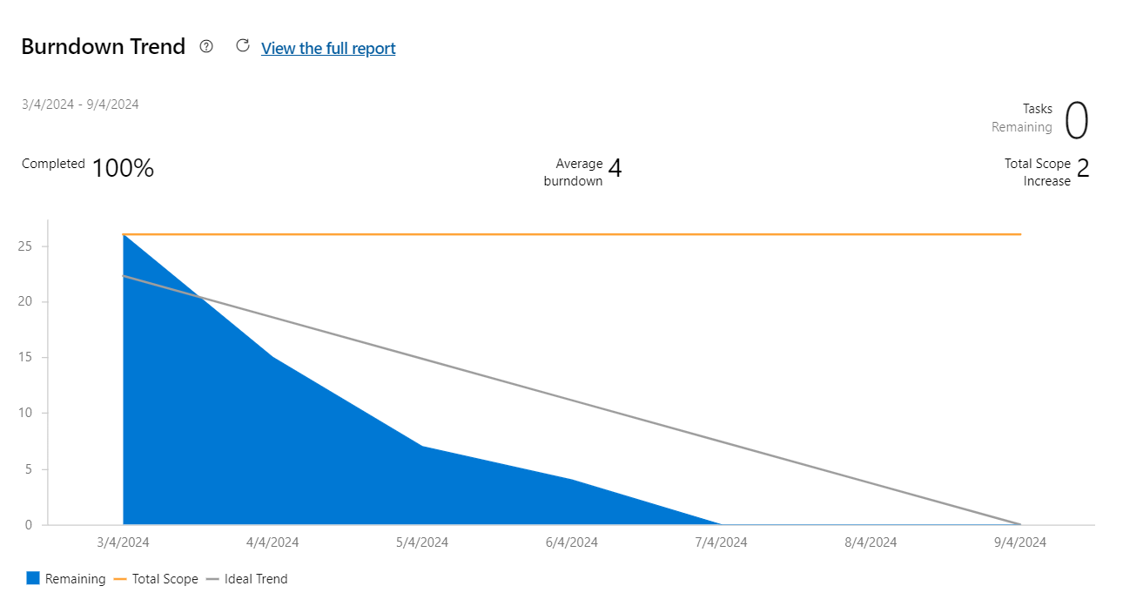
Sprint Planning 3
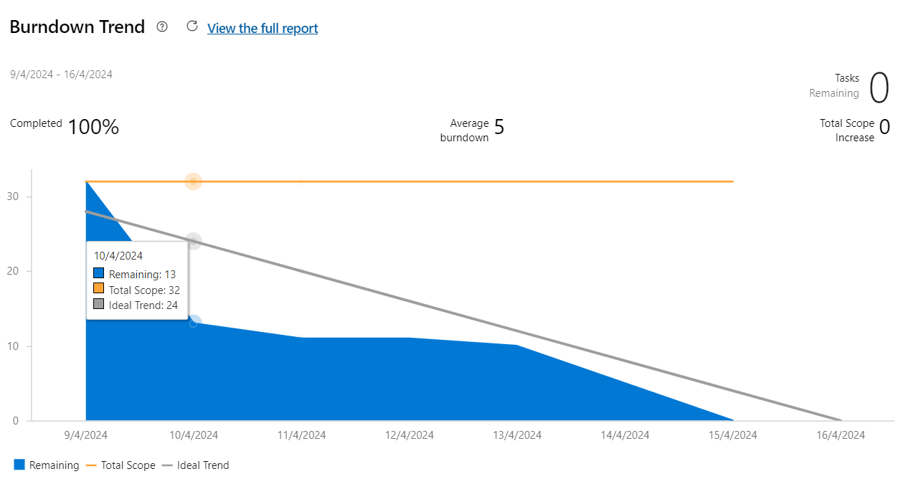
Sprint – Planning 4

